**LAB 4**

**Introduction:**

In this lab we are going to create a ionic native app using ionic cli and we are gonna call different api to create web service and test the ionic app.

**Prerequisites:**

* Ionic cli
* Code editor
* Node.js and npm
* Ionic lab for testing and deployment
* Api keys

**Implementation:**

* First we should install node.js and npm globally through that install ionic cli globally with the command

**“ npm install -g@ionic/cli”**

* Now it will ask for capacitor integration and install it and later install cordova and other packages.
* Now install vs code and create a project in ionic and install all the packages to that app,you can select a template while installing the app.
* Now, write the code for login and register pages and adjust the root modules and now you all are set to run your app.
* We kept login and register pages and when you login with correct credentials you will get redirected to search bar.
* This is how the project is done and now for api we selected the search api from google and you can also search for images for different type.

**Output screenshots:**

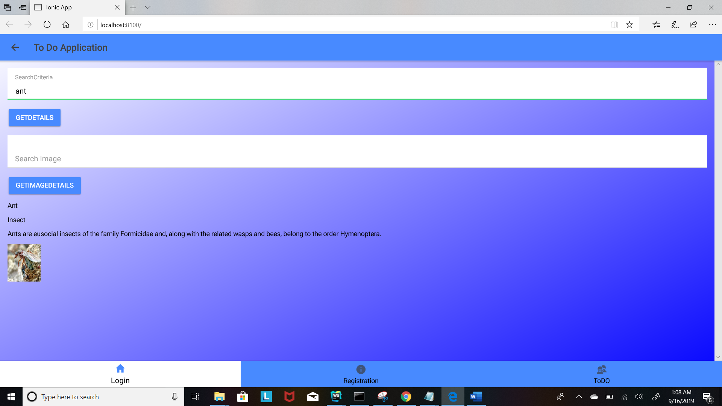

This is how the output of different images looks like.

**Conclusion:**

We have learned how to create apps in ionic cli and we learned how to call api to this app and we learned about different testings.

Assignment done by:

Name class:id

Karishma yallanki 29

Tejaswi guturu 16